# Q1. WAP to read data from the keyboard, write into a file called “INPUT.txt”, again read from the file, and print the data on the screen.

#include <stdio.h>

#include <stdlib.h>

int main()

{

    FILE *f1;

    char c;

    printf("Data Input\n\n");

    f1=fopen("INPUT.txt","w");

    while((c=getchar())!=EOF) putc(c,f1);

    fclose(f1);

    printf("Data Output\n\n");

    f1=fopen("INPUT.txt","r");

    while((c=getc(f1))!=EOF) printf("%c",c);

    fclose(f1);

    return 3;

}

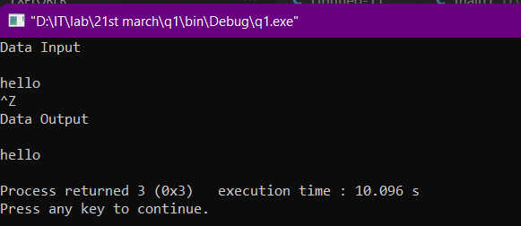

# Q2.A file named “DATA.txt” contains a series of integer number. WAP to read these numbers and write odd numbers into a file “ODD.txt” and even numbers into “EVEN.txt” and then display the contents of both files.

#include <stdio.h>

#include <stdlib.h>

int main()

{

    FILE *f1,*f2,*f3;

    int num,number,i;

    printf("Enter how many entries : ");

    scanf("%d",&num);

    printf("Contents of DATA file : ");

    f1=fopen("DATA.txt","w");

    for(i=1;i<=num;i++)

    {

        scanf("%d",&number);

        if(number==-1) break;

        //here putw is not reflecting the number in txt file

        //thus used fprintf

        fprintf(f1,"%d ",number);

    }

    fclose(f1);

    f1=fopen("DATA.txt","r");

    f2=fopen("ODD.txt","w");

    f3=fopen("EVEN.txt","w");

    for(i=1;i<=num;i++)

    {

        fscanf(f1,"%d",&number);

        if(number%2==0)

            //*importance of space is that it helps in distinguishing between numbers*

            //if we don't use space then the single no. will be stored in either EVEN.txt or ODD.txt file

            fprintf(f3," %d",number);

        else

            fprintf(f2," %d",number);

    }

    fclose(f1);

    fclose(f2);

    fclose(f3);

    f3=fopen("EVEN.txt","r");

    f2=fopen("ODD.txt","r");

    printf("Contents of ODD file : ");

    //this loop works till the eof is reached

     while(!feof(f2)){

        //read from the file

        fscanf(f2,"%d",&number);

        //print to the console

       fprintf(stdout,"%d ",number);

        //printf("%d",number);

    }

    printf("\n\n");

    printf("Contents of EVEN file : ");

    while(!feof(f3)){

        //read from the file

        fscanf(f3,"%d",&number);

        //print to the console

       fprintf(stdout,"%d ",number);

        //printf("%d",number);

    }

    printf("\n\n");

    fclose(f2);

    fclose(f3);

    return 3;

}

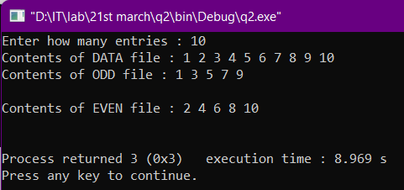

# Q3. Open a file called “Student.txt” and write data into it in the format: ID,name,branch,grade. Read the file and display the contents in tabular manner.

#include <stdio.h>

#include <stdlib.h>

#include <string.h>

int main()

{

    int i,j,k;

    FILE *fp;

    char id[10];

    char name[15];

    char branch[4];

    char grade[4];

    int num;

    printf("Enter the no of records you want to enter : ");

    scanf("%d",&num);

    fp=fopen("STUDENT.txt","w");

    //loop for taking in data to the file from the console

    for(i=0;i<num;++i){

        printf("ID : ");

        scanf("%s",id);

        fprintf(fp,"%s ",id);

        printf("NAME : ");

        fflush(stdin);

        gets(name);

        //scanf("%s",name);

        fprintf(fp,"%s ",name);

        printf("BRANCH : ");

        scanf("%s",branch);

        fprintf(fp,"%s ",branch);

        printf("GRADE : ");

        scanf("%s",grade);

        fprintf(fp,"%s\n",grade);

        //  \n for printing from the nxt line

        printf("\n");

    }

    fclose(fp);

    fp=fopen("STUDENT.txt","r");

    printf("\nID NAME BRANCH GRADE\n");

    //loop for taking the data from the file and printing it to the console

    for(i=0;i<num;++i){

        fscanf(fp,"%s ",&id);

        printf("%s ",id);

        fscanf(fp,"%s ",&name);

        printf("%s ",name);

        fscanf(fp,"%s ",&branch);

        printf("%s ",branch);

        fscanf(fp,"%s ",&grade);

        printf("%s ",grade);

        printf("\n");

    }

        fclose(fp);

    return 3;

}

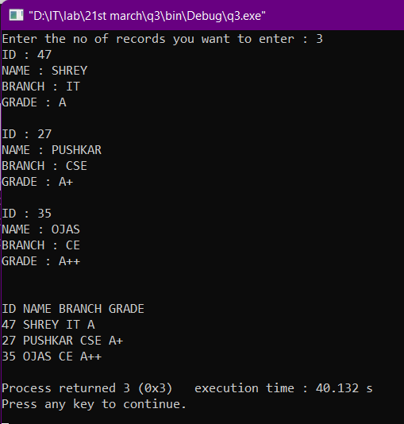

# Q4. Copy the contents of one file to another.

#include <stdio.h>

#include <stdlib.h>

#include <string.h>

int main()

{

    int i,j;

    FILE *f1,*f2;

    char details[30];

    f1=fopen("original.txt","w");

    //taking input from the console and printing it to the file

    printf("Enter the details ...\nAnd press 0 to exit...\n");

    for(i=0;i<30;++i){

        scanf("%c",&details[i]);

        if(details[i]!='0'){

            fprintf(f1,"%c",details[i]);

        }

        else{

            break;

        }

    }

    fclose(f1);

    f1=fopen("original.txt","r");

    f2=fopen("copied.txt","w");

    //copying the data of file 1 to file 2

    j=0;

    while(!feof(f1)&(j<i-1)){           /*here j<i-1 is used to remove the 0 from the copied file*/

        fscanf(f1,"%c",&details[j]);

        fprintf(f2,"%c",details[j]);

        ++j;

    }

    fclose(f1);

    fclose(f2);

    printf("\nThe data inside the file 2 (ie the copied file is)...\n");

    f2=fopen("copied.txt","r");

    i=0;

    while(!feof(f2)){

        fscanf(f2,"%c",&details[i]);

        printf("%c",details[i]);

        ++i;

    }

    fclose(f2);

    return 3;

}

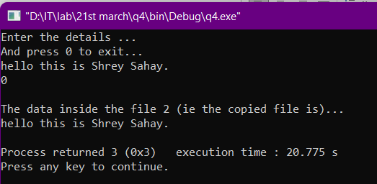

# Q5. Compare two files and return 1 if equal and 0 otherwise.

#include <stdio.h>

#include <stdlib.h>

#include <string.h>

int main()

{

    char i[20];

    char j[21];

    FILE *f1;

    f1 = fopen("Q.5a.txt", "w");

    char c[20];

    printf("Enter any string for file1: ");

    gets(c);

    fprintf(f1, "%s", c);

    fclose(f1);

    f1 = fopen("Q.5a.txt", "r");

    fgets(c, 20, f1);

    printf("Entered string for file1 : ");

    puts(c);

    fclose(f1);

    FILE *f2;

    f2 = fopen("Q.5b.txt", "w");

    char ch[21];

    printf("Enter any string for file 2: ");

    gets(ch);

    fprintf(f2, "%s", ch);

    fclose(f2);

    f2 = fopen("Q.5b.txt", "r");

    fgets(ch, 21, f2);

    printf("Entered string for file2 : ");

    puts(ch);

    fclose(f2);

    f1 = fopen("Q.5a.txt", "r");

    f2 = fopen("Q.5b.txt", "r");

    strcpy(i, fgets(c, 20, f1));

    puts(i);

    strcpy(j, fgets(ch, 21, f2));

    puts(j);

    if (!strcmp(i, j))

        printf("Two files are equal");

    else

        printf("Two files are not equal");

    return 3;

}

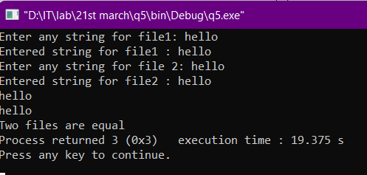

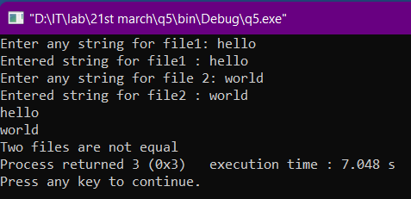

# Q6. Modify question3 to create a BILL.txt file to store: ItemID , Name, Quantity, Rate, Price. Read the prices and print the items as a bill with the total bill amount.

#include <stdio.h>

#include <stdlib.h>

int main()

{

    FILE *fp;

    fp = fopen("bill", "w");

    char name[20];

    int item_id, qty, rate, i, n;

    float price, sum = 0;

    printf("how many entries\n");

    scanf("%d", &n);

    printf("enter all datas\n");

    for (i = 1; i <= n; i++)

    {

        fscanf(stdin, "%d %s %d %d", &item_id, name, &qty, &rate);

        fprintf(fp, "%d %s %d %d\n", item_id, name, qty, rate);

    }

    fclose(fp);

    printf("\n\n");

    fp = fopen("bill", "r");

    printf("item_id\tname\tqty\trate\tprice\n");

    // fseek(fp,0L,0);

    for (i = 1; i <= n; i++)

    {

        fscanf(fp, "%d %s %d %d", &item_id, name, &qty, &rate);

        price = qty * rate;

        sum += price;

        fprintf(stdout, "%d\t%s\t%d\t%d\t%f\n", item_id, name, qty, rate, price);

    }

    fclose(fp);

    fp = fopen("bill", "a");

    fprintf(fp, "\ntotal amt=%.2f", sum);

    fclose(fp);

    printf("\ntotal amt=%.2f", sum);

    return 3;

}

